Birla Institute of Technology & Science, Pilani
Work-Integrated Learning Programmes Division
Second Semester 2020-2021

Comprehensive Examination
(EC-3 Regular)

Course No. : SS ZG653
Course Title : SOFTWARE ARCHITECTURES
Nature of Exam : Open Book
No. of Pages = 4

No. of Questions = 4
Weightage : 45%
Duration : 2 Hours
Date of Exam : Saturday, 01/05/2021 (FN)
Note:
- Please follow all the Instructions to Candidates given on the cover page of the answer book.
- All parts of a question should be answered consecutively. Each answer should start from a fresh page.
- Assumptions made if any, should be stated clearly at the beginning of your answer.

  - Case Study: Bus Transport Corporation [28]

Company ABC, Ltd has been approached by a City Bus Transport Corporation (CTBC) for a custom development contract. You are the Application Architect at ABC, Ltd. The information shared by CTBC is summarized below
- CTBC operates about 6000 buses and intends to add another 2000 buses in the next 2 to 3 years; they own 45 depots
- CTBC has 50 bus stations (terminals) – typically where a trip starts
- CTBC operates on 400 different routes; they serve people through 3000 bus shelters (bus stops) over and above the bus stations
- The primary goal of the project is to provide Real-time Information (Bus Timings, ETA etc) on LCD/LED Display Boards at Bus Stops, Bus Terminals and other identified locations.
You, as an architect had discussions with the IT team at CTBC and collected the following information
- Every bus has a bus id. All the routes are also numbered. On each route, there are multiple trips. A bus on the road is identified by bus-id, route-no and trip-no. It has a start time when the trip starts
- The size (number of lines) of the display boards varies depending on the location.
- It is expected that the display shows information about the next few trips
- CTBC will invest in additional infrastructure to track the buses
- CTBC team mentioned multiple times about Uber like service

In the internal discussions at ABC, it was concluded that Back-end data will be critical for the success of the project. Your GM has asked you to come out with a document with the following information which can be used for further discussions. He has asked you to make appropriate assumptions.

- Create a Solution Design – how will the application achieve the primary objective
- Draw the module view of the application(s) involved in the system, with a one-line description of each module; high light various HW components needed for the system
- Define the back-end data format and contents, that will enable the display, how does the data get updated?
- Recommend a cloud-based architecture. Represent it with a diagram (s). Highlight architecture style (s), pattern(s) and relevant tactics
- Highlight specific patterns for high availability and scalability (Note: they are adding additional busses)
- One of the key success factors for the system is: “the passengers getting the right arrival information about the buses”. Name two quality attributes that will enable this. Justify your answer with detailed explanations.
- With a sequence diagram explain the logic of displaying the arrival information in the Display board kept in the bus shelter

  - Case Study: Smart City [28]

You are an architect for a set of Smart City Projects in your companies(?). Your company has decided to propose a new project to the Government to increase the use of City Buses in major cities. Your idea came from a limited survey. Many of the existing and potential users of the bus services complained about the lack of arrival information at the bus stops. Your manager asked you to meet with officials in the Transport Corporation to know more about their operation. This is the summary of the meeting
- A Major transport corporation operates in excess of 5000 buses and typical number routes they serve is about 400. In each route there are minimum of 15 to 20 bus stops.
- Every bus has been assigned an id number. Every route has an id. There are multiple trips in a route. For example, a bus starting at 8 AM in a route will be called trip 1. The second bus starting at 8:15 in the same route will be call trip 2 etc
- A bus on the road is identified by bus-id, route-no and trip-no.
You have internal brainstorming on the project. The summary of the meeting is
- We need to have LCD display boards in each of the bus shelters
- The LCD should display arrival time of the buses coming to that bus stop
- Bus Tracking is the key requirement of the project…more like Uber
- Develop Project document with the following information(?), which can be used for further discussion

- Create a Solution Design – how will the application achieve the primary objective
- Draw the module view of the application(s) involved in the system, with a one-line description of each module; High light the various HW components needed for the solution to work
- Define the back-end data format and contents, that will enable the displays; please note the core of the application collect, calculate and display data
- Recommend a cloud-based architecture. Document the architecture with diagrams. Highlight architecture style (s), pattern(s) and relevant tactics
- Highlight specific patterns for high availability and scalability (so that larger coporations can use the solution)
- One of the key success factors for the system is: “the passengers getting the right arrival information about the buses”. Name two quality attributes that will enable this. Justify your answer with detailed explanations.
- With a sequence diagram explain the logic of displaying the arrival information in the Display board kept in the bus shelter

  - Case Study: Project Green [28]

You are a senior application architect. At a social gathering, you met with your old friend who is into environment protection. He was worried about the increasing number of private vehicles on the road and was wondering how to encourage people to take public transport. He expects the government to add more buses and feels that could be one of the solutions.

After a few days, you need to go to the airport to catch a flight. You notice a few things during your trip to the airport. You book an Uber to come pick you up, there is a notification for ETA (expected time of arrival). When you are in the Uber, you can see the expected time to destination. Even at the airport there are displays showing ETD (expected time of departure) of your flight. You realize that this lack of information at the bus stops probably discourages people in using public bus transport. You decide to work on a potential solution.

You did some research and also met with employees in the transport corporation. The summary of your research
- A bus on the road can be uniquely identified by Bus-Id.Route-No.Trip-No
- The transport corporation owns many busses
- They operate on multiple routes
- Each route had many Bus stops
- There are multiple trips in each route. For example, when one says that every one hour there are buses between Point A and Point B from 5AM to 10 PM, it means there are 18 trips in that route.
- Bus tracking is the key problem to be solved

You discuss this with your colleagues and as a first step decide to create a document with the following information. The assumption is to have display boards in all the bus stops that will display the ETA of the buses in that particular bus stop.
- Create a Solution Design – how will the application achieve the primary objective
- Draw the module view of the application(s) involved in the system, with a one-line description of each module; High light the various HW components needed for the solution to work
- Define the back-end data format and contents, that will enable the displays
- Recommend a cloud-based architecture. Represent it with a diagram (s). Highlight architecture style (s), pattern(s) and relevant tactics
- Highlight specific patterns for high availability and scalability (so that larger corporations can use the solution)
- One of the key success factors for the system is: “the passengers getting the right arrival information about the buses”. Name two quality attributes that will enable this. Justify your answer with detailed explanations.
- With a sequence diagram explain the logic of displaying the arrival information in the Display board kept in the bus shelter

- You have been hired as a consulting architect by a large company XYZ, Ltd. They are in the process of architecting an Enterprise application for internal use. They have asked you to help them to decide between SOA, Container and FAAS – when to use what, by way of scenarios. [6]

- For each of the above patterns, provide two scenarios, where the pattern will be more useful
- Justify your answer.

- You have been hired as a consulting architect by a large company XYZ, Ltd. They are in the process of architecting an Enterprise application for internal use. They have asked you to help them to decide between Microservices, Container and FAAS – when to use what, by way of scenarios. [6]
- For each of the above patterns, provide two scenarios, where the pattern will be more useful
- Justify your answer.

  - You have been hired as a consulting architect by a large company XYZ, Ltd. They are in the process of architecting an Enterprise application for internal use. They have asked you to help them to decide between SOA, Microservices, Container and FAAS – when to use what, by way of scenarios. [6]
- For each of the above patterns, provide two scenarios, where the pattern will be more useful
- Justify your answer

Common for all
https://rubygarage.org/blog/monolith-soa-microservices-serverless
Monolithic software architecture can be beneficial if your team is at the founding stage, you’re building an unproven product, and you have no experience with microservices.

The SOA approach is best suited for complex enterprise systems such as those for banks

Consider choosing a microservices architecture when you have multiple experienced teams and when the app is complex enough to break it into services. When an application is large and needs to be flexible and scalable, microservices are beneficial.

Serverless software architecture is beneficial for accomplishing one-time tasks and auxiliary processes. It works great for client-heavy apps and apps that are growing fast and need to scale limitlessly.

https://www.serverless.com/blog/serverless-faas-vs-containers/
Choose containers and container orchestrators when you need flexibility, or when you need to migrate legacy services. Choose serverless when you need speed of development, automatic scaling and significantly lowered runtime costs.

  - Create a check list for Mobile App developers on when to use Native vs Web app models. Check list should be in the form of example scenarios [6]

- For each of the above Mobile App Development models, provide three scenarios where the model will be more useful
- Justify your answer

  - Create a check list for Mobile App developers on when to use Native vs Hybrid models. Check list should be in the form of example scenarios [6]

- For each of the above Mobile App Development models, provide three scenarios where the model will be more useful
- Justify your answer

  - Create a check list for Mobile App developers on when to use Hybrid vs Web app models. Check list should be in the form of example scenarios [6]

- For each of the above Mobile App Development models, provide three scenarios where the model will be more useful
- Justify your answer

Common for Native v/s hybrid v/s web app

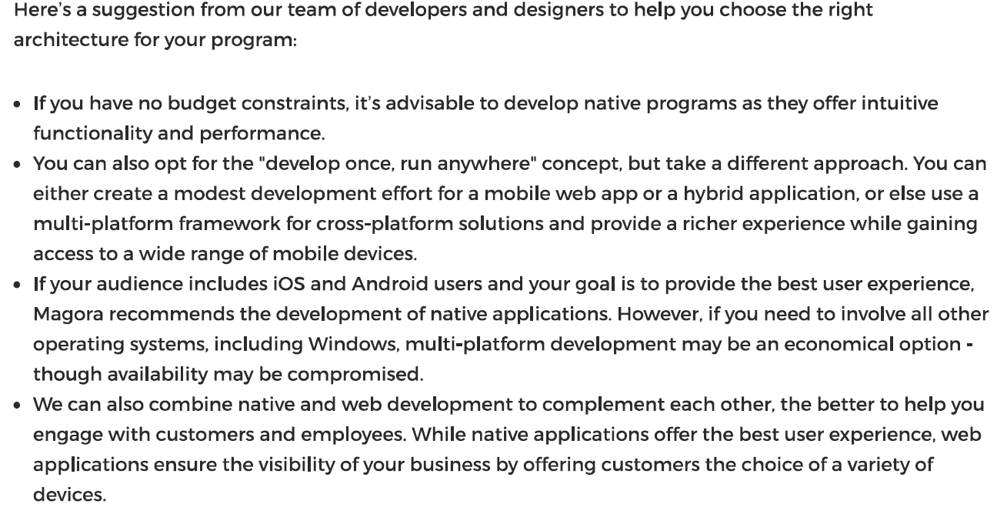

https://markovate.com/blog/native-vs-hybrid-vs-web-mobile-app-development-services/
Pros | Cons
- Native apps have high performance and speed.  - The hardware resources required are few because of the efficient coding.  - They have optimized UI/UX because of the native environment of development  - They can increase app usage by the ability to leverage push notifications accordingly to your desired requirements.  - Native apps can function offline usually. | - More development cost and time.  - Similarly, maintenance and updates also take more time.  - No code flexibility for different operating systems

Pros | Cons
- Lesser development time and cost than native eventually.  - Able to access native features of the device.  - Supports multiple platforms through a single codebase at the same time.  - Easy deployment of updates in particular.  - Ability to work without internet as well as in cases where database support is not required. | - Less in performance than native apps in short.  - Some features might miss in a certain operating system generally.  - Moreover, customizations might require more costs.  - Have to adjust to two platforms simultaneously which can affect the UI of one or the other.  - Difficult to run on older devices and browsers.

Pros | Cons
- Faster development time and lesser cost  - No limitation of app stores thus the easy distribution of the app  - Supports multiple platforms with a single codebase generally  - Faster updates in the absence of an app store | - Cannot fully access the capabilities of a device specifically  - Certainly, slower speed than native  - Does not work without the internet in particular

  - Hardware Manufacturers claim that multicore processor improves performance. Software architects use design tactics to improve Software performance.
How do they work together? Use the following format to give the answer. [5]

- Explain Multi Core
- Name the Software Design tactic(s) enabled / supported by multicore
- How does the multicore enable the implementation of the design tactic(s)?

  - Using private and public key infrastructure, How can we prevent fake job offers. Make necessary assumptions [5]

  - One sees the message “Do Not Close This Window (Or Click The Back Button)” especially while doing banking transaction.
What is happening behind the scenes? [5]

https://www.quora.com/Why-dont-payment-gateway-pages-support-Back-Button-Refresh

Redirection of PG to Bank site To and Fro does some kind of information exchange as both Merchant site asking for payments and PG a well as Bank are seperate financial payments value chain entity.
PG seats in between Merchant and the bank/ card payments authorisation and such financial system needs trace and audit logs as digital forensic record or proof.
These system each time has generated unique number for request sent to PG/Bank for payments request authorisation with transaction key with date, time, merchant ID, session ID ( Auto generated number) and many more such information. All these transaction keys are unique and traceable for its source and fate of transactions.
If you REFRESH than you are trying to send old digital transaction keys again which may not honored or processed. Once these authorisation request is passed to other system except waiting for response for next entity to take the browser control and give output on screen.
Note: E-commerce terms Security, Authorisation, Non Repudiation, Accountability can be searched for further explanation of why these logs and records are needed.

https://www.lyra.com/in/payment-gateway-integrations/#:~:text=Most%20of%20the%20merchants%20accepting,authorizes%20and%20processes%20online%20payments.

Hosted payment gateway integration or payment in redirection –
This type of payment gateway integration redirects the customer to a secure payment page.
This payment page is hosted by a payment service provider.
Here payment gateway acts as a third party as the customer needs to leave (redirected) the merchant’s website to complete the payment.
After the buyer is redirected to the payment page, he/she needs to enter the payment details on the page and then proceed to the payment.
After the purchase is done, the customer gets redirected back to the merchant’s website and the checkout process gets completed.
Hosted payment gateways are simple to use and easy to set up and they are customizable.
All the payment processing is taken care of by the payment service provider who provides the hosted payment page.
And as for the security of transactions, the merchant just has to choose a PCI compliant payment service provider.
Most online payment service providers nowadays are PCI compliant and also offer fraud protection.
The only disadvantage of using this type of integration is as this uses an externally hosted page, the merchant cannot control the user experience when it comes to making payments.
https://www.chetu.com/blogs/payments/how-to-integrate-a-payment-gateway-into-a-website.php

How Does a Payment Gateway Work?
You can think of a payment gateway as a virtual bridge that connects a customer with an online business or ecommerce store. It is the final step in the sales process. For security purposes, payment gateways encrypt the data they transmit. Some automatically look for fraud and add tax. Here are some of the individual steps performed by payment gateways:
- The customer places an order by entering their credit card information and clicking on "pay now" or equivalent.
- The customer's web browser uses secure socket layer (SSL) to encrypt the credit card information for security purposes.
- The merchant forwards the information to the payment gateway using SSL.
- The payment gateway forwards the information to the appropriate payment processor.
- The payment processor forwards the data to the appropriate credit card association.
- The credit card association evaluates the request and sends an answer back to the payment processor.
- The payment processor forwards the answer to the payment gateway.
- The payment gateway forwards the answer to the customer and to the merchant. At this point, both the customer and the merchant know whether or not the transaction was approved.
- At a later time, the merchant sends all approvals to the credit card company in batch form.
- The credit card company transfers funds to the merchant for all credit card transactions that were approved.

********

